**Government Polytechnic Arvi**

**A**

**Project Report**

**On**

**“E PAGAR BOOK AND ATTENDANCE SYSTEM”**

**A Project Report Submitted in Partial Fulfillment of the Requirement for the award of**

**Diploma in Computer Engineering**

**of the Maharashtra State Board of Technical Education**

**2020-2021**



**Submitted By**

**Mr. ROHIT B. HARSHE**

**MR.PRATIK V. DAHAT**

**MR.SUMIT R. RAUT**

**MISS.SHRADHA A. GHAGRE**

**Final Year Student of Electrical Engineering**

Under the Guidance Of

**Professor M.K. TATTE**

Lecturer in Computer Engineering Department.

**Department of Computer Engineering**

**Government Polytechnic, Arvi District-Wardha**

2020-2021

CERTIFICATE

This is to certify that Project entitled

**“E Pagar Book and Attendance System”**

Which has been submitted by,

**Mr. ROHIT B. HARSHE**

**MR.PRATIK V. DAHAT**

**MR.SUMIT R. RAUT**

**MISS.SHRADHA A. GHAGRE**

**Final Year Student of Computer Engineering**

during the academic year 2020-2021 in the partial fulfillment of the requirement of the

**Diploma in Computer Engineering**

Prescribed by the Maharashtra State Board of Technical Education, Mumbai is the record of their own work carried out by them under my guidance and to my satisfaction.

**Guided By**

**Professor M.K. TATTE**

**Lecturer in Computer Engineering Department**

**Prof. Dr. M.A.Ali Professor S. R. Thute**

**H.O.D Principal**

**Department of Government Polytechnic,Arvi**

**Computer Engineering**

**Government Polytechnic Arvi**

**Acknowledgement**

It is indeed a great pleasure of us to present this project report after having undergone unforgettable moments of excitement, anxiety, experience and understanding. This pleasure would not have been accomplished without the support of extended to us by our guide **Professor M.K. Tatte** of Government Polytechnic, Arvi who not only encourage us through the venture but also to great pain in going through the manuscript carefully and correction which have greatly improved the quality of the text.

We would like to thanks to our principal **Professor S. R. Thute sir** And **Professor Dr.M.A.Ali** HOD of Computer Department.

Last but not least we wish to thank all teaching and non-teaching staff and all our Friends who directly or indirectly help us in our Work.

**Declaration**

**We hereby declare that the project entitles “E Pagar and Attendance System” has not been submitted by any other university.**

**Date: -**

**Place: - Government Polytechnic Arvi**

* **Mr. Rohit B. Harshe __________________**
* **Mr. Pratik V. Dahat __________________**
* **Mr.Sumit R. Raut __________________**
* **Miss. Shradha A. Ghagre __________________**

**Abstract**

E Pagar Book and Attendance System is a free employee management, work & payroll management, where you can manage all your staff and employee’s attendance, and employees and their salary. Payments & advances can also be recorded in this app. Use E Pagar Book and Attendance System for free as a worker management system or attendance management app. E Pagar Book and Attendance System attendance manager allows business owners or managers to track the employee’s punch-in & punch-out time. Best and easiest solution for employee management, E Pagar Book and Attendance System is also available for computers to use in any browser. No download needed. It’s the ideal web site for every business, offices, daily labour management, worker management, staff management and any kind of field or remote teams.

E Pagar Book and Attendance System enables you to manage staff’s salary and your business accounting in the same app as well through its cash book feature. Its salary manager is smart and can automatically calculate the salary, overtime, advance payments and any other spends on employees. Salary calculator is also capable of calculating and can be a payroll manager. Many industry leaders are using E Pagar Book and Attendance System to manage their payroll. Overtime calculators and advance payment recorders ensure accurate payout to employees and save money and chaos in business management. In one stop business management solution E Pagar Book and Attendance System, every business can keep their financial transactions and cash flow records. Accounting and bookkeeping rich features make E Pagar Book and Attendance System an ideal and full- fledged solution for any business.

Keywords— IT, TP, PCE, CV, TPO

|  |  |  |
| --- | --- | --- |
| **Sr.no** | **Content** | **Page no.** |
| 1 | Introduction | 1-3 |
| 2 | Literature review | 4 |
| 3 | System Analysis | 5-9 |
| 4 | Implementation and Testing | 10-14 |
| 5 | Database Design | 15 |
| 6 | Result analysis | 16-21 |
| 7 | Conclusion | 22-23 |
| 8 | Reference | 24 |

**Content**

1. **Introduction**

This project is aimed at developing an online application for Admin and Employee of company to gets the information about attendance, Salary, Notification, etc. The System is an online application that can accessed thought the organization with proper login provided.

E-pagar book and attendance system is a platform that provides interface between Employee and Company. The administrator plays an important role in our project. Administrators logging may also put attendance of employee. They can add employee logins and updating. System provide the feature of sending File related to companies to selected employee. They also set a notification to stay update about works in companies.

System provides the feature to employee to see attendance of her/him, see notification in the login page of employee login. They can able to see and access the file sent by the admin to employee. They can able to change the password of login. The key feature of this project is that it attendance and salary. The users can access the data easily in no time. In the first page there are login page for admin and employee also. This feature helps in many ways like saving cost, time and paper work this shows the paperless environment.

Main modules in training placement cells are:

* Employee Module
* Admin Module

### Employee Module:

* Employee of the company is the user of this application.
* Registered Employee can login using unique username and password.
* Employee can change their login password by using email Id and old password.
* Employee can see notification after click notification tab.
* Employee can see the file send by the admit after click on File tab.
* Employee can see the salary record of the any month .
* Employee can see the attendance attend by the admin.
* Employee can watch their profile on profile tab

### Admin Module:

* Admin has supreme power of application.
* Admin is responsible for maintaining the whole system.
* Admin have privileges to add, remove and edit the employee.
* Admin can send file to the selected employee.
* Admin can set notification.
* Admin can set attendance to employee.
* Admin can change him /her login credential.

## Present Available System

In various company admin store data of employee manually on paper. There is complication of update , add or remove the data. Admin take attendance by manual way it cause missing of data or data lose.and it time consuming process.

Admin store data of employee salary on paper its complicated to manage the store data on paper. employee not able to see their attendance , salary or notification about company properly.

For transferring of any document to specific or all employee they use third party application is cause problem in data security. May be data will be corrupt or may be hacker will hack the data.

## Need of New System

In previous days, company had all the process is done manually. In order to avoid the existing problem of company for their future we are design existing system as E- pagar book and attendance system, so whatever the notification admin has to pass to the employee can inform online. Employee profile is maintained in the database, it gives more security to data, ensures data accuracy, reduces paper work and save time. The system can be used as an application for taking data of employee salary and attendance online it reduce time, it’s also environment friendly.

Employee will get salary information and attendance at any time .They will also get the information of previous month, day or year at any time simply. Employee will get all the notification send by the admin. Employee will get the document send by the admin properly with totally secure service .Employee can see their own profile in profile module

# Aim and Objectives

The Aim of the project is Employee can stay update about salary, he will get information of attendance, stay update because they will get notification about company and work at project. Admin can store all employee data in a project that effects reducing in data loss.

# Objective

The main Objectives of this System are as

* Maintain individual Employee record.
* Send documents by using official site to secure a data.
* Creating Database.
* Maintain salary record.
* Maintain Attendance record.

# **LITERATURE REVIEW**

Now a day’s admin can store data of employee on paper that cause a data lose, time consuming process, environment unfriendly, lack of security of data. And this process is difficult when number of employee working. Employee had not got information of salary, attendance properly.

To overcome to this problem, we develop an online application for we use java programming language. Java is perfectly acceptable and workable for web development and actually better than .net and Python. Java is a general Programming language. It is an Object Oriented, static type language.

From his experience if we use the right web development tool then java is definitely a great language for web development.

Java is perfectly fine for small website, you can get JSP pages working very quickly with a Java Web Server such as Tomcat. The main reason for large company choosing Java over other solution is because it is considered to be much more secured.

### Features of Java

* Java is truly platform independent programming language that support many operating system as well as type of hardware.
* Java is highly scalable programming language.
* Java is an open source language, which means it is available free of cost.

# **SYSTEM ANALYSIS**

System analysis is a process of gathering and interpreting facts, diagnosing problems and the information about the Student Feedback System to recommend improvements on the system. It is a problem solving activity that requires intensive communication between the system users and system developers.

System analysis or study is an important phase of any system development process. The system is studied to the minutest detail and analyzed. The system analyst plays the role of the interrogator and dwells deep into the working of the present system. The system is viewed as a whole and the input to the system are identified. The outputs from the organizations are traced to the various processes. System analysis is concerned with becoming aware of the problem, identifying the relevant and decisional variables, analyzing and synthesizing the various factors and determining an optimal or at least a satisfactory solution or program of action. A detailed study of the process must be made by various techniques like interviews, questionnaires etc. The data collected by these sources must be scrutinized to arrive to a conclusion. The conclusion is an understanding of how the system functions. This system is called the existing system. Now the existing system is subjected to close study and problem areas are identified..

* The new system should be cost effective.
* To expand management, improve productivity and services.
* To enhance user / system interface.
* To improve information quality and usability.
* To upgrade systems reliability, availability, flexibility and growth potential.

## Proposed System Work

Feasibility study is a preliminary study undertaken to determine and documents a projects viability. The purpose of feasibility study is not to solve the problem, but to determine the problem is worth solving. The term feasibility study is also used to refer to the resulting document. These results of this study are used to make a decision whether to proceed with the project or table it. If it indeed leads to a project being approved, it will – before the real work of the proposed project starts – be used to ascertain the likelihood of the project success. It is an analysis of possible alternative solutions to a problem and a recommendation on the best alternatives. The Feasibility Study concentrates on the following, such as Operational Feasibility, Technical Feasibility.

It is to find out whether the current work practices and procedures support a new system.

Operational Feasibility study tests the operational scope of the software to be developed.

Also, Social factors i.e. how the organizational changes will affect the working lives of those affected by the system.

This involves questions such as whether the technology needed for the system exists, how difficult it will be to build, and whether the firm has enough experiences using this technology. The assessment is based on an outline design of system requirement in terms of Input, Processes, Output, Fields, Program and Procedures. Technical Feasibility study compares the level of technology available in the software development and the level of technology required for the development of the product.

Design is the first step in the development phase for any techniques and principle for the purpose of defining a device process or system in sufficient detail to permit its physical realization. System design is the process of defining architecture, components, module and data for system to satisfy specified requirements. System design could be seen as the application of a system theory to product development.

The system design document is a required document for every project. It should include a high-level description of why the system design document has been created, provide what the new system is intended for or is intended to replace and contain detailed descriptions of the architecture and system components.

Once the software requirements have been analyzed and specified the software design involves three technical activities – design, coding and implementation and testing that are required to build and verify the software.

The design activities are of main importance in this phase, because in this activity decision ultimately affecting the success of the software implementation and its ease of maintenance are made. This decision has the final bearing upon reliability and main ability of the system. Design is the only way to accurately translate the customer’s requirement into finished software or a system.

Design is the place where quality is fostered in development. Software design is a process through which requirements are translated into a representation of software. Software design is conducted in two steps. Preliminary design is concerned with the transformation of requirements into data.

* + 1. **DATA FLOW DAIGRAM**

A data flow diagram (DFD) is a graphical tool used to describe and analyze the movement of data through a system by depicting the flow of data, storage of data, source or destination of data and the processes that respond to change in data. The DFD is one of the most important tools used by the system analysts to model system components.

## DFD For Student

username

**Employee**

**password**

**New user**

**Existing**

* **DFD For Admin**

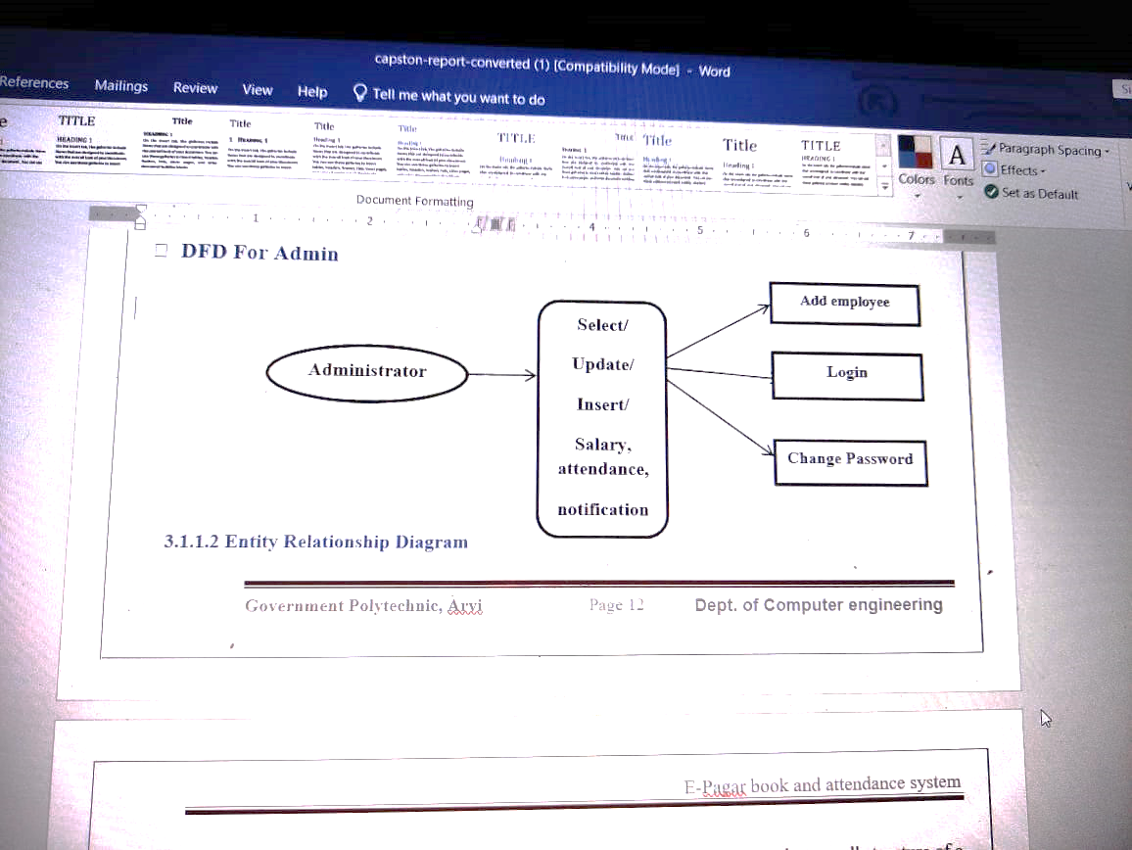

* + - 1. **Entity Relationship Diagram**

An Entity Relationship Diagram (ERD) is a graphical tool to express the overall structure of a database. An entity is a place, person, thing or event of interest to the organist ion and about which data are captured, stored or processes. The attribute are various kinds of data that describe an entity.

An association of several entities in an, Entity Relationship model is called relationship.

An ERD consists of the following major components

### Rectangle:

Used for representing entity types.

### Ellipse:

Used for representing attribute.

### Diamond:

Used for representing relationship types

### Lines:

Used for linking attributes to entity type

**E-R DIAGRAM**

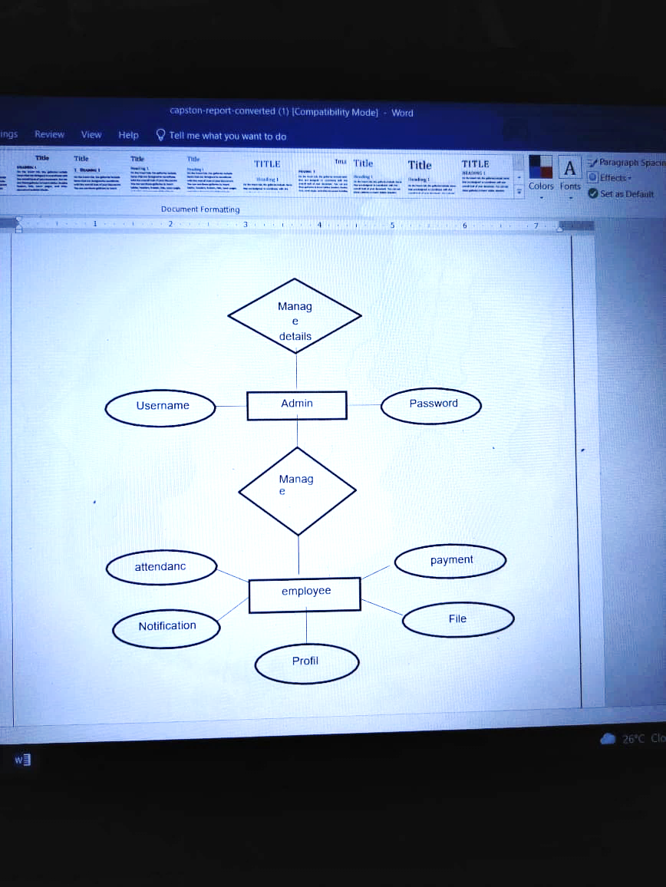

1. **IMPLEMENTATION AND TESTING**
   1. **Hardware and Software Requirement**

* **Hardware Requirement** Hardware**:** Processor Intel Operating System: Windows 10

Browser: Google chrome, Mozilla Firefox Database: My Access

RAM: 4 GB

Processor: Intel Pentium

## Software Requirement

**MySQL** is a relational database management system (RDBMS) developed by Oracle that is based on structured query language (SQL).

A database is a structured collection of data. It may be anything from a simple shopping list to a picture gallery or a place to hold the vast amounts of information in a corporate network. In particular, a relational database is a digital store collecting data and organizing it according to the relational model. In this model, tables consist of rows and columns, and relationships between data elements all follow a strict logical structure. An RDBMS is simply the set of software tools used to actually implement, manage, and query such a database

### Apache Tomcat web Server

* **Front End:** JAVA SCRIPT, HTML, CSS
* **Back End:** MySQL, JAVA

## Testing

Testing is the stage of implementation, which is aimed at ensuring that the system works accurately and efficiently before live operation commences. The logical design and physical design are thoroughly and continually examining on paper to ensure that they will work when implemented.

Thus, the system test in implementation was a confirmation that all is correct and opportunities to show the user that the system work.

Testing of the online classified system was performed in three stages which are as follows:

### Unit Testing

* **Integration Testing**
* **System Testing**
* **Browser compatibility testing**

**Unit Testing:**

Unit testing is under taken when a module has been coded and successfully reviewed. This can be done by two methods:

1. Black Box Testing
2. Equivalence class Partitioning

### Black Box Testing

Black box testing is referred as behavioral testing. Black box testing is mainly related to functional requirement of the software.

Black box testing focus on information domain and deliberately ignores control structure.

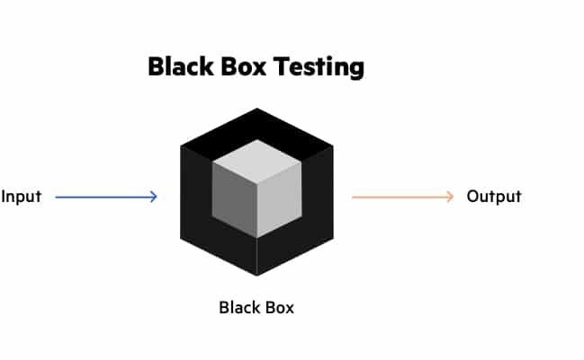Back box testing is performed during or in latter stage of software program.

### Equivalence class partitioning

The domain of the input values to a program is partitioned into a set of equivalence classes. This partitioning is done on such way that the behavior of the program is similar to every boundary value analysis. Boundary value analysis leads to section of the test case at the boundaries of the different equivalence classes.

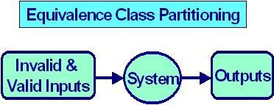In our project particularly, first we create the login form and then by running the form we conclude and tested that whether it runs properly or not. So, such a way we perform the unit testing and, in this way, we have done the testing to the all forms.

## Integration Testing

During integration testing different modules of the system are integrated using integration plan. The integration plan specifies the steps and the order in which modules are combined to realize the full system.

Purpose:

* To test whether the module performs its intended task.
* Once all the modules have been integrated and tested, system testing can start.

## System Testing:

System testing are designed to validate a fully developed system with a view to assuring that it meets its requirement. There are three types of system testing which are as follows.

* Alpha Testing
* Beta Testing
* Test case Design

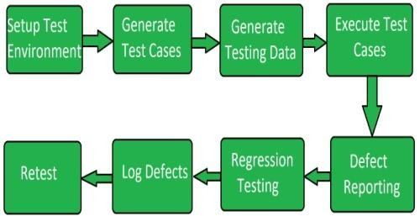

## BROWSER COMPATIBILITY TESTING

Compatibility testing is to check the application working in the same way for all platforms. We all might have observed that some websites are not properly displayed on some browsers and we just think that the website is broken. But, as soon as you open it on a different browser, the website opens up just fine. Thus this behavior explains the compatibility of a website with different browsers. Each browser interprets the information on the website page differently. Thus, some browsers may lack the features that your website is trying to show and make your website look broken on that browser.

Common Compatibility testing defects

* Changes in UI ( look and feel)
* Change in font size
* Alignment related issues
* Change in CSS style and color
* Scroll bar related issues
* Content or label overlapping
* Broken tables or Frames

# **Database Design.**

A database is an organized collection of structured information, or data, typically stored electronically in a computer system. A database is usually controlled by a database management system (DBMS). Together, the data and the DBMS, along with the applications that are associated with them, are referred to as a database system, often shortened to just database.

Data within the most common types of databases in operation today is typically modeled in rows and columns in a series of tables to make processing and data querying efficient. The data can then be easily accessed, managed, modified, updated, controlled, and organized. Most databases use structured query language (SQL) for writing and querying data. In a relational database, digital information about a specific customer is organized into rows, columns and tables which are indexed to make it easier to find relevant information through SQL or NoSQL queries. In contrast, a graph database uses nodes and edges to define relationships between data entries and queries require a special semantic search syntax. As of this writing, SPARQL is the only semantic query language that is approved by the World Wide Web Consortium (W3C). Typically, the database manager provides users with the ability to control read/write access, specify report generation and analyze usage. Some databases offer ACID (atomicity, consistency, isolation and durability) compliance to guarantee that data is consistent and that transactions are complete. Following technologies are used to develop the database.

* MySQL
* JSP (Java Server Pages)

## Screenshots:

1. **RESULT ANALYSIS**

* In this page admin can login by using user name password.

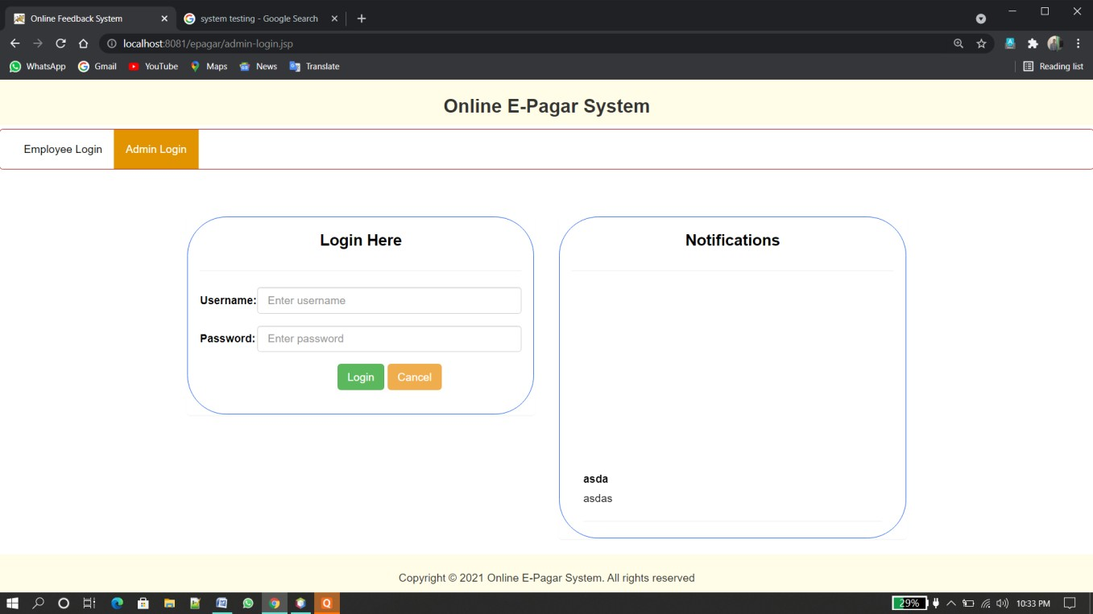

## Fig. Admin Login Page

* In which Employee can login by using username and password

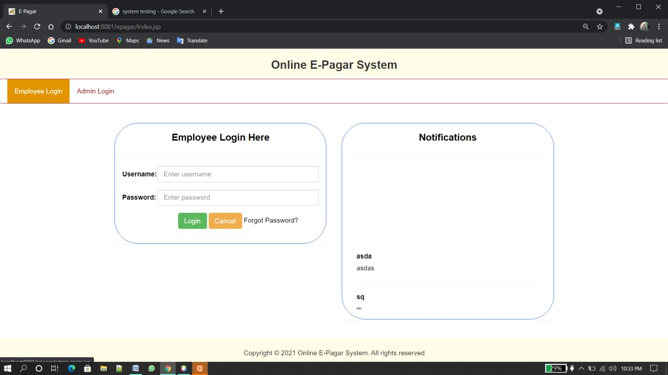

## Fig. Employee Login Page

* In this page Admin can add, update, remove the employee

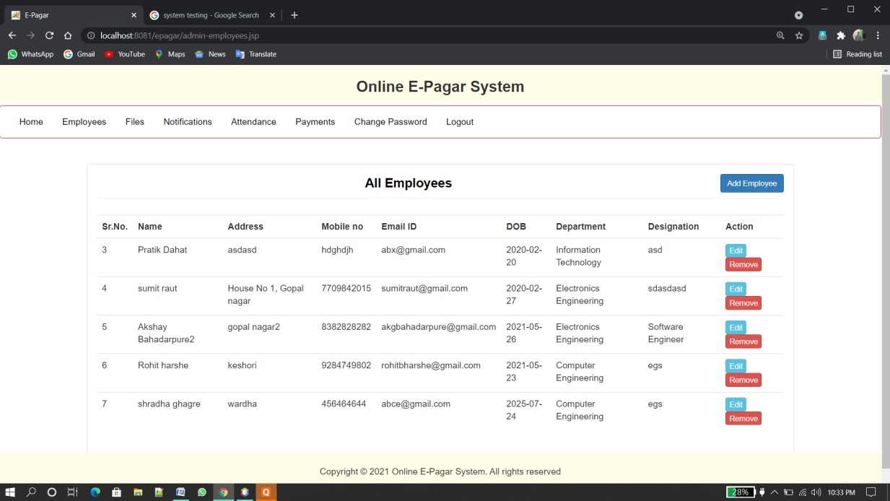

## Fig. Employee add ,update Page

* In this page Admin can send documents to the employees.

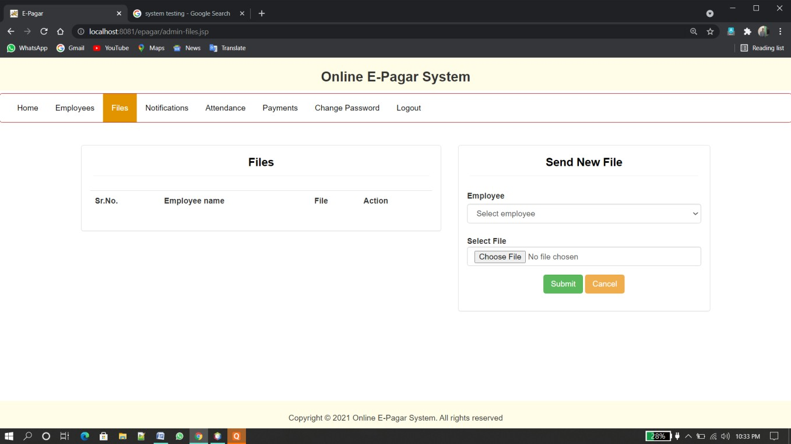

## Fig. Document adding Page

* In this page admin can store employee salary information

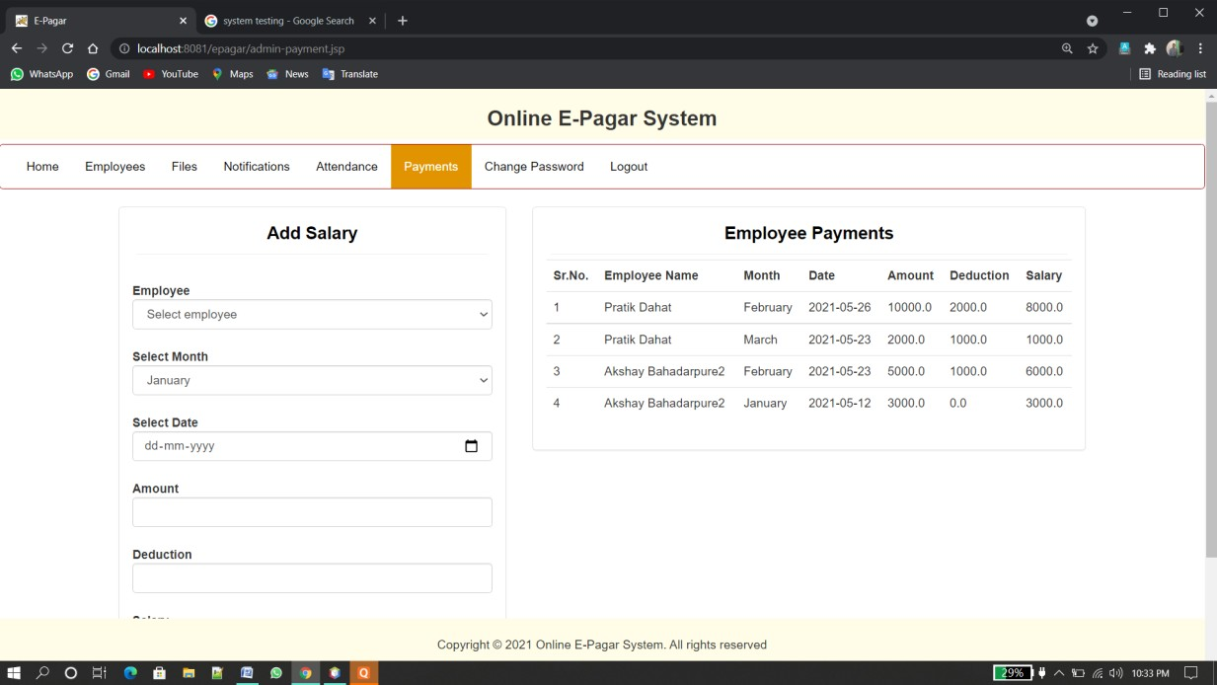

## Fig. Salary setting page

* In this page admin can store attendance of employee

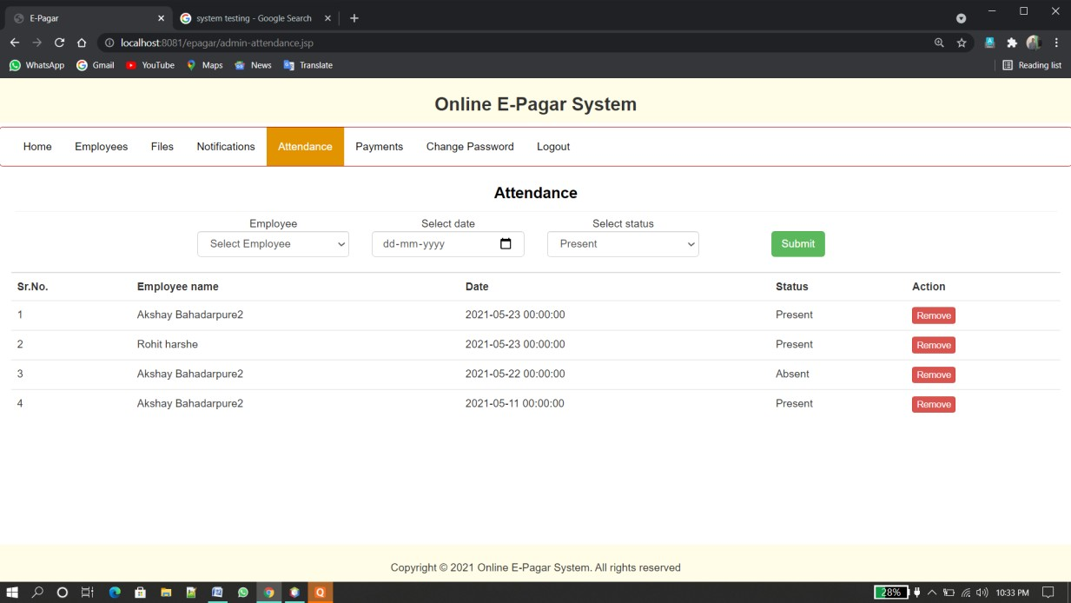

## Fig. Attendance Page

* In this page Employee can view the documents send by admin

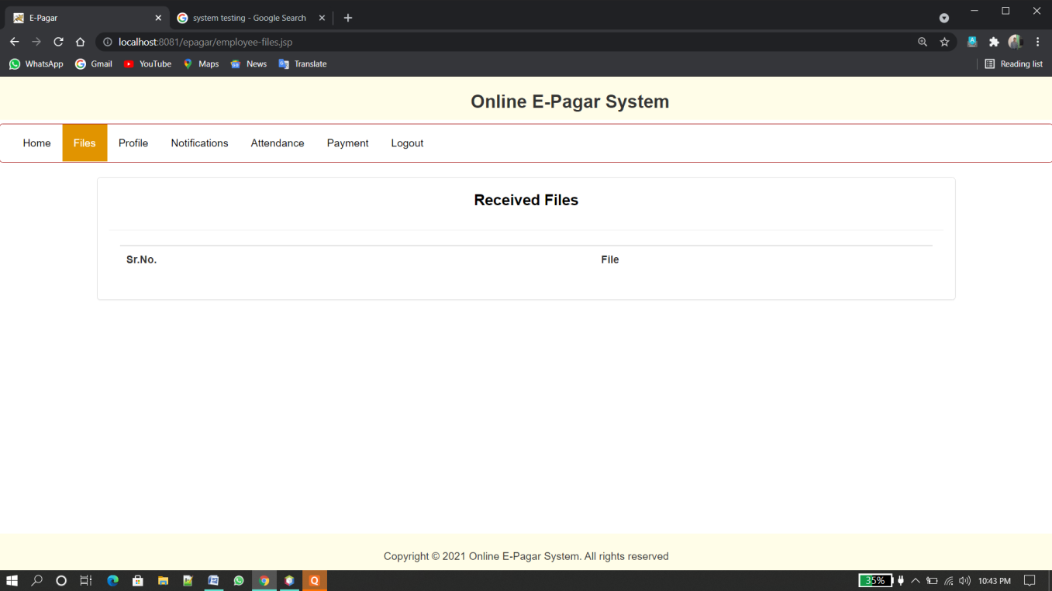

## Fig. Employee document manage page.

* In this page employee can see their profile

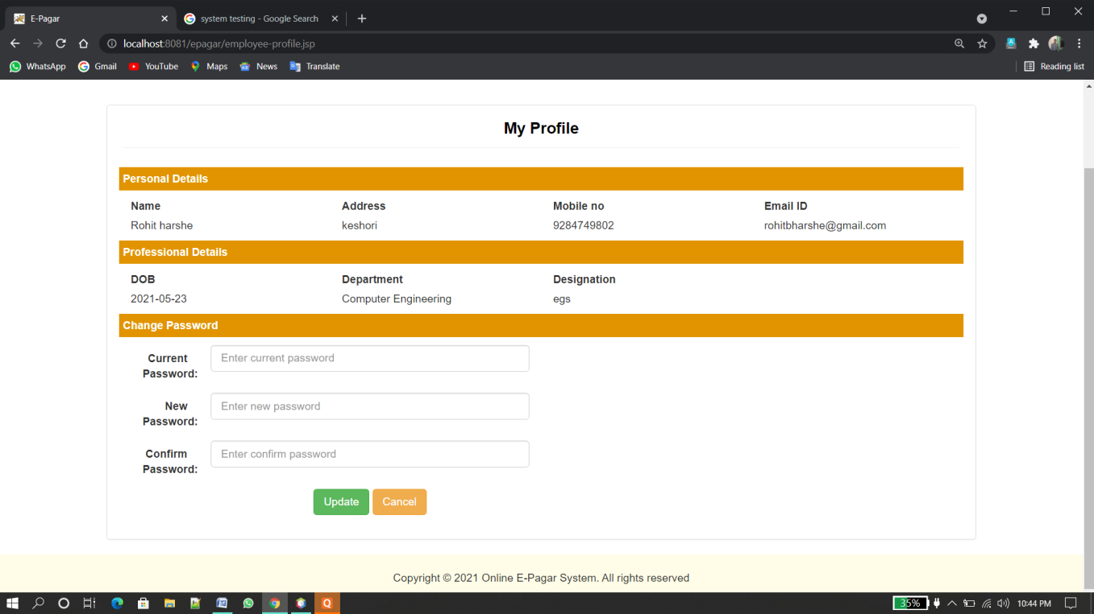

## Fig. Profile Page

* 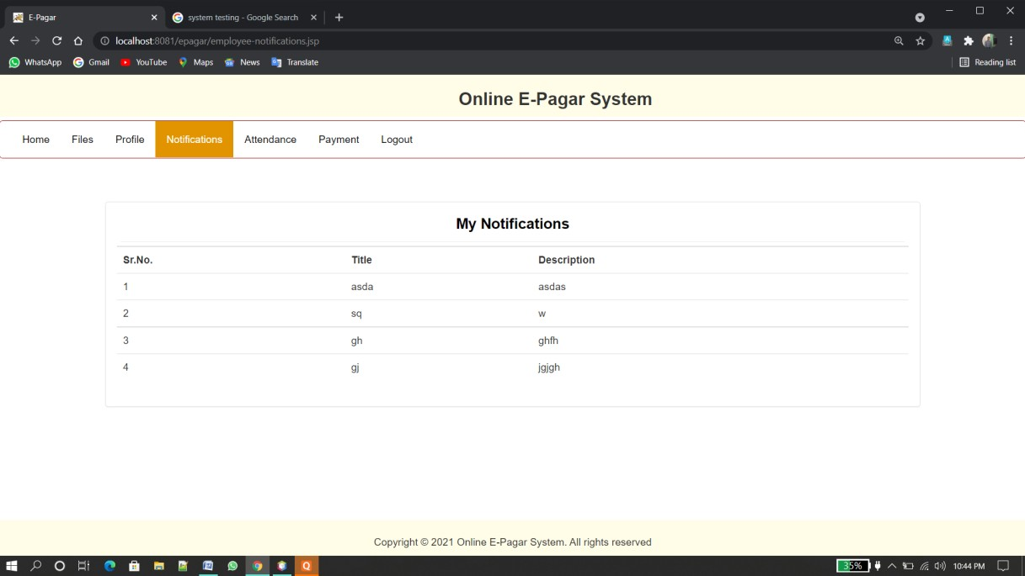In this page employee can notification set by admin

## Fig. Notification Page

* + In this page employee can see attendance attend by the admin

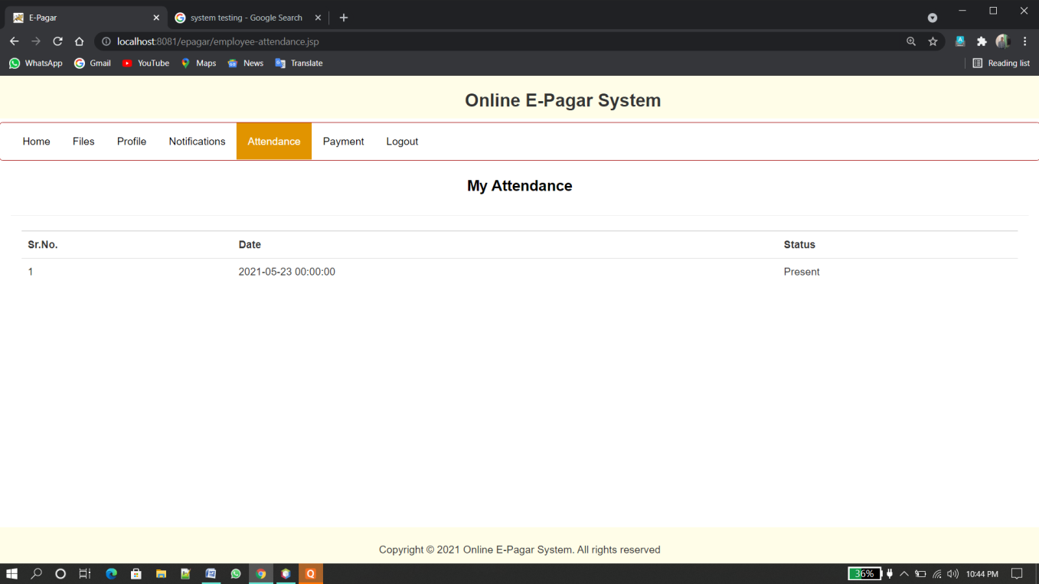

## Fig. Attendance page

### In this page employee can see payment information

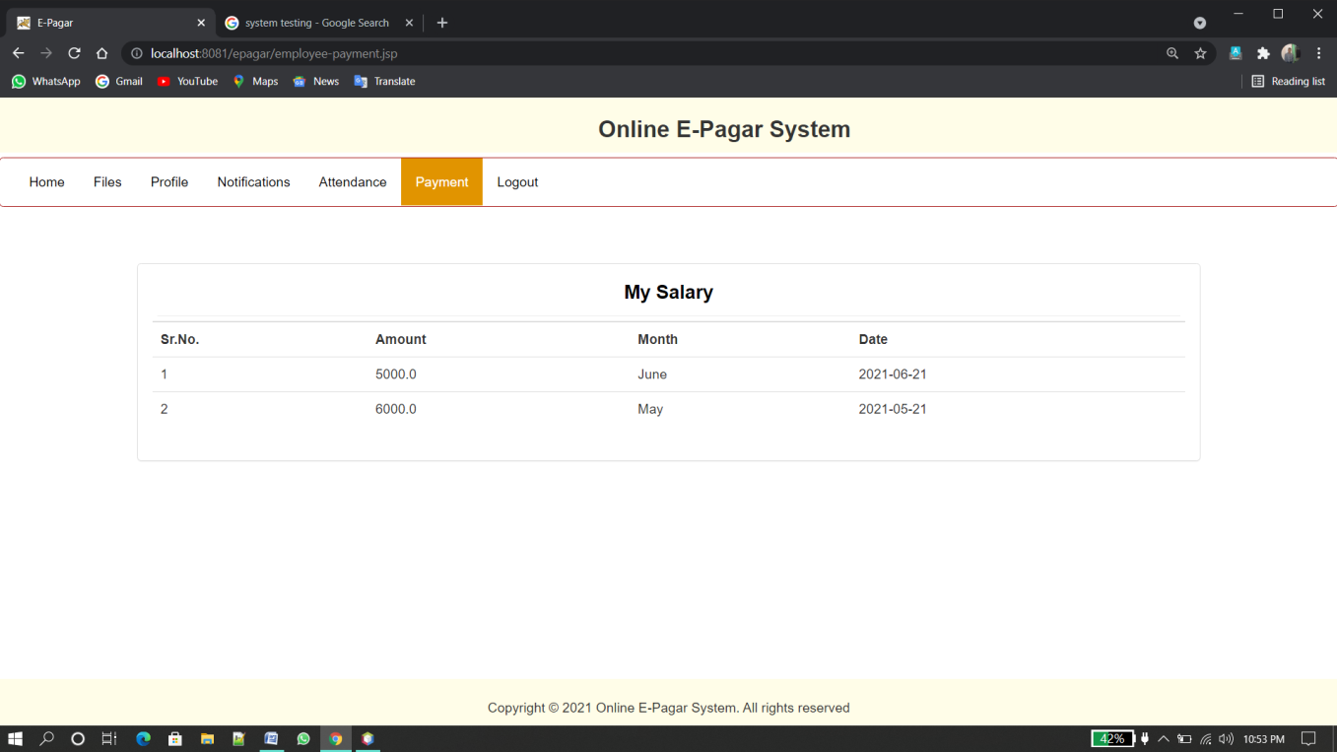

**Fig. Payments Information page**

1. **CONCLUSION**

The introduction, problem definition of the project has been completed successfully to company by maintaining the employee details related to attendance, salary information, sending file in an efficient manner. Comparing to existing computerized system, it performs at a faster pace.

Forms are very user friendly. This project is easy to understand in the sense that there are button for navigation to each page and it has benefited the developer in the sense the various concept of core java while working on the project.

The system has been developed with much care that it is free of errors and at the same time it is efficient and less time consuming. This project will successfully implement the database technology to transform the manual database management system into a automated format. All goals for first phase of the project are implemented successfully. They can easily get information of attendance, salary, notification by login.

## 7.1 FUTURE SCOPE

The project is easily extensible and can be improved by further incremental releases of the same. New module can be easily added as it requires only an addition of a new package on button click. Our project has a big scope to do. Admin can access previous information of all Employee.

Though our project is itself matured enough but still betterment is always an open door. In this case also we can add some features to this software to make this software more reliable. The project performs its intended functions with required precision, hence is very reliable. The project is very flexible and any modification can be made to the existing system to suit changes that can take place in future. The online processing of the project is very simple following the existing method without any changes and suitable validation are provided for easy and correct access to user.

The forms are design in such a way that any end user easily understand less effort is required to learn, operates. Security is the most important features of the proposed system.

# **REFERENCES**

* G. J. Myers, the Art of Software Testing. New York: Wiley, 1979.
* I. Goldberg, D. Wagner, R. Thomas, and E. A. Brewer, "A secure environment for untrusted helper applications," in Proc. 1996 USENIX Security Syme., July 1996, pp. 1-13.
* Freeman, R, Lewis, R. (1998) planning and Implementing Assessment, Kogan page, London.
* Herbert schildt a leading authority on the complete reference: Java Seventh Edition, and is a master window programming.
* [www.wikipedia.com](http://www.wikipedia.com/)
* [www.tutorialspoint.com](http://www.tutorialspoint.com/)
* [www.w3scholl.com](http://www.w3scholl.com/)